GRADE | 10 | SUBJECT |  | CAT |  | WEEK |  | W4  L5 |  | TOPIC | Solution Development: Word Processing –Tables: Design- Styles, Borders and Shading
LESSON SUMMARY FOR:
DATE STARTED |  |  |  |  |  |  | DATE COMPLETED
LESSON OBJECTIVES |  |  | At the end of this lesson the learner must be able to:  - Know how to change the design of a simple table  Using Table Styles, Borders and Shading
TEACHER ACTIVITIES |  |  |  |  |  |  |  |  | LEARNER ACTIVITIES |  |  |  | TIMING | RESOURCES NEEDED
1. Methodology  - Classroom Hands On activity  - Power point presentation  - Text book  2. Introduction  Revise inserting of a table (see learner activities )  3. Main Body (Lesson presentation)  Insert a table or use an existing table  To apply a table style:  - Select the table that you want to format.  - Click a table style from the gallery of table styles on  the Design tab, on the Table Tools tab.  Note: Within a table cell, you can use styles and direct formatting to format the content of the cell.  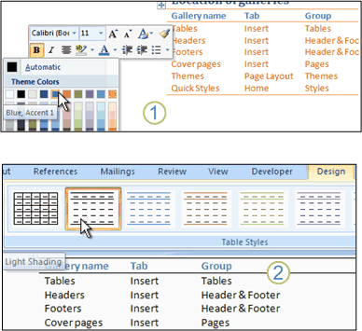  Borders & Shading  Use the same table above  - Highlight your table  Hint: (To highlight the entire table, click inside the first cell. Hold  your left mouse button down, and drag your mouse to the  bottom right cell)  - With the entire cell highlighted, click on Table from the menu bar  - From the drop down menu, click on Table Properties  - The Table Properties dialogue box appears  - Click the Table tab strip, then click the Borders and Shading button at the bottom  - The Borders and Shading dialogue box appears  - You should have the Border tab strip selected, as in the image below:  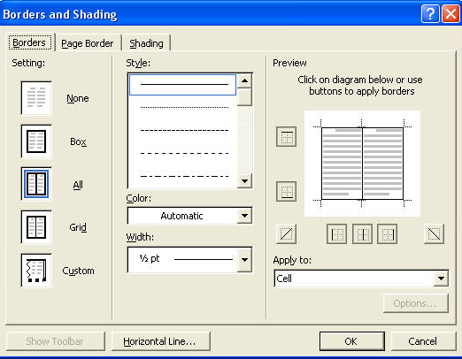  Change your Style section to match the image on the right of the two below:  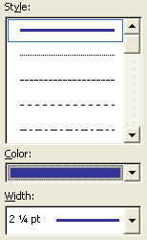  You can choose any settings you like for the Border colour.  Do the same as above for Shading – only choose the Shading Tab before affecting any changes  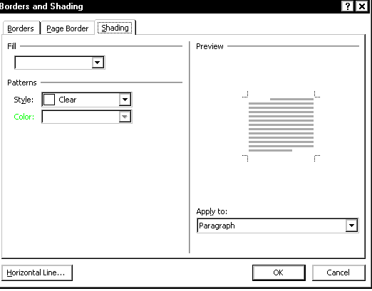  Source:  http://www.homeandlearn.co.uk/MW//s9p4.html  4. Conclusion  Let learners experiment with all aspects introduced |  |  |  |  |  |  |  |  | Folder DataFiles_Solutions for learners to practice  Computers  Part of your Life  p.242 Act 7  Via Afrika  p.139 Act 22 |  |  |  | Introduction and definition 10 minutes  The rest of the time allocated on explanation of the lesson | PowerPoint presentation  Data projector  Prescribed Textbooks  Computers  Part of your Life  p.241-242  Via Afrika  p.139  Focus  p.155-156

Name of Teacher: HOD:
Sign: Sign:
Date: Date:

